The main questions:
- What sensors should we use to measure skin resistance?
- How to correctly connect two schemes of the glove and bracelet so that we will take one analog output? (Maybe some of the similar schemes, or how-to-do videos, your own answer)
Qivita project – the smart glove and bracelet that measure electropuncture and pulse diagnostics and sends the final diagnosis to the app on the smartphone.
For the diagnosis of the organism, the studies of the biologically active points of Reynold Foll were taken as a basis. Through these points, weak DC currents (up to 1.5 μA) and a voltage of up to 1.5-2 V are conducted. Using the obtained results, we obtain information about the resistance exerted by human skin and determine the diagnosis of the organism using the Foll method.
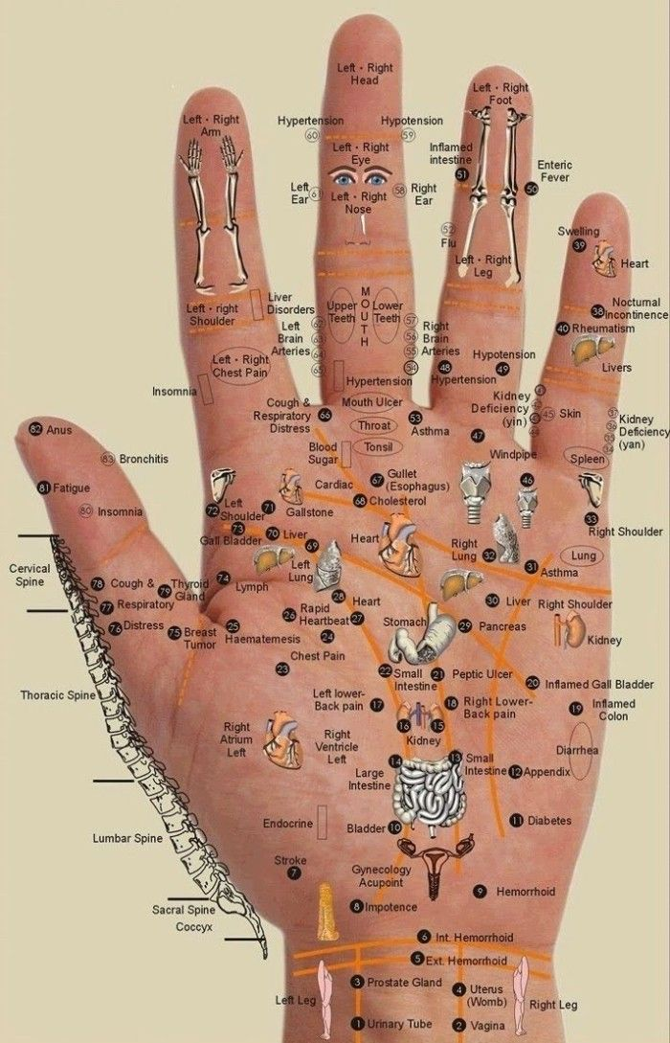
Picture 1. Location of all of biologically active points (acupuncture points) on the left hand
To measure resistance, a plasma ball was created that forms an electromagnetic field and it is enough for a man to just put on a special glove with the sensor coils on his left hand and bring it to the ball. Each spiral coil consists of 10 turns and a low-resistance material. From the action of the plasma ball inside the sensor coils, an induction current arises which, through the biologically active points, is amplified by an operational amplifier and the data is measured with a microammeter with a voltmeter. We process them and read them to LEGO. By dividing the voltage by the current, the resistance from each sensor at the points of the left palm is calculated. LEGO compares the results of deviation from the norm and saves them as a variable for the further definition of a person's diagnosis.
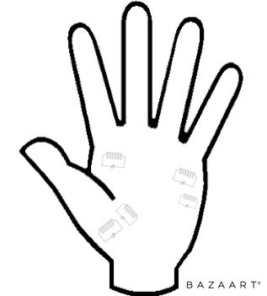
Picture 2. The location of coils in the glove
The correct operation of this device is also affected by human temperature and skin moisture at the time of measurement. To eliminate the error, a temperature sensor and two humidity sensors were added to the glove.
This method can give a diagnosis with an accuracy of 56%. To improve the performance, a heart rate monitor was added measuring pulse diagnosis at three points on the wrist of the hand.
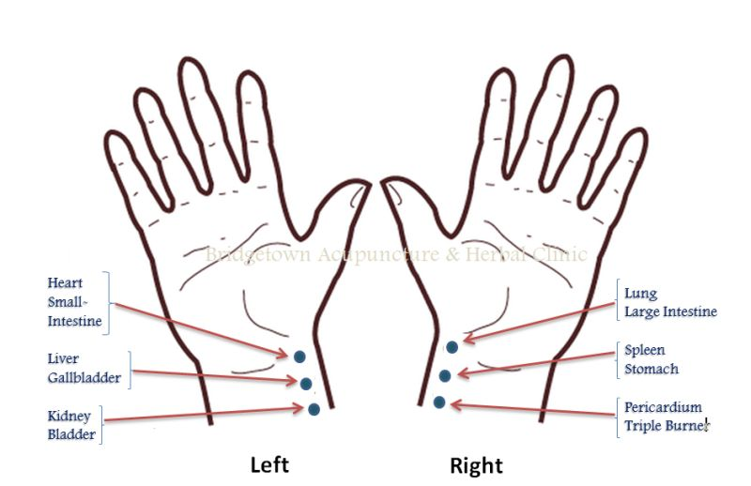
Picture 3. Acupuncture points to measure pulse diagnostics
At these points we measure strength, rhythm, pulse shape. We compare these numbers by tabular values ​​and enter them into LEGO as the second variable. This variable will also be used to further determine the diagnosis of a person. The measurement operation is performed up to 10 times until the variable from the heart rate monitor is comparable with the variable from the glove. With a comparable value of variables, the device is more likely to detect up to 86% of the diagnosis of the organism and stores it in a separate variable on LEGO. The entire diagnostic process takes up to 8 minutes.

Schemes:
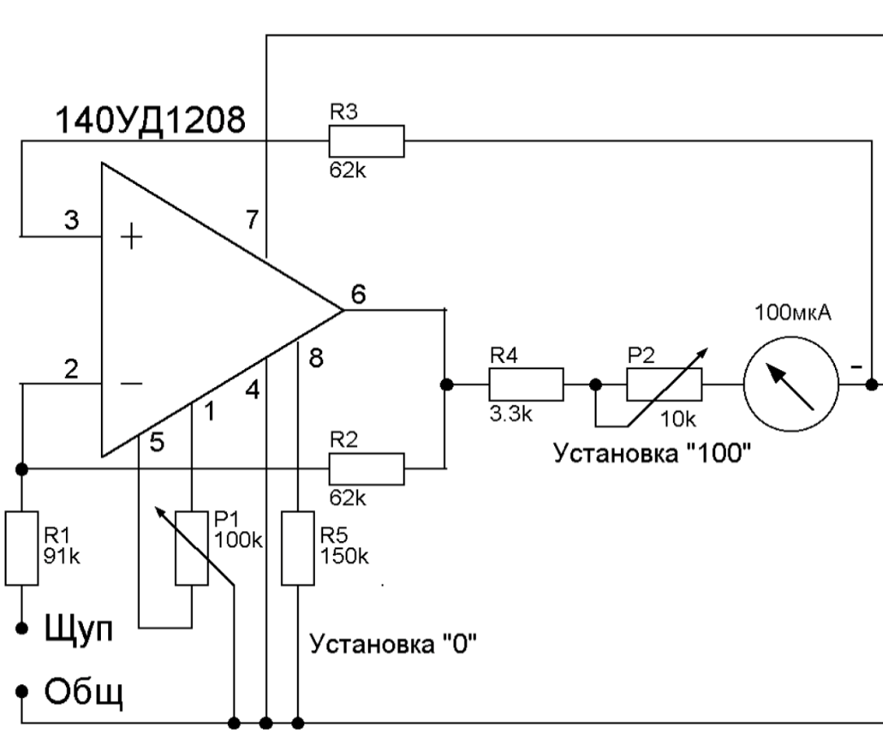
Picture 4. The scheme of device based on Foll method
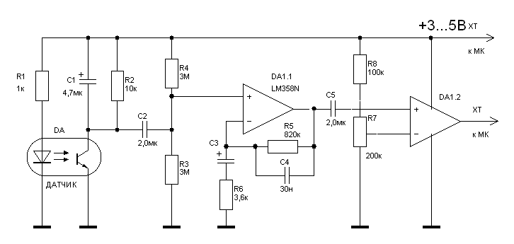
Picture 5. The scheme of heart rate monitor
P.S “Датчик” is a sensor

